Easy Read
Summary Document

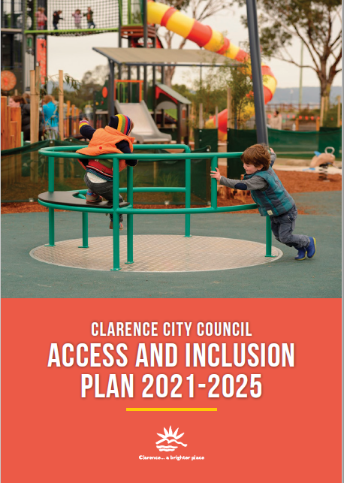
Why access and inclusion?
It is important to be inclusive. Inclusion means being involved. This helps the whole community.
Having access means you are able to move around in the community. You can get into places and spaces, get information and services, get a job, play sport and enjoy life.

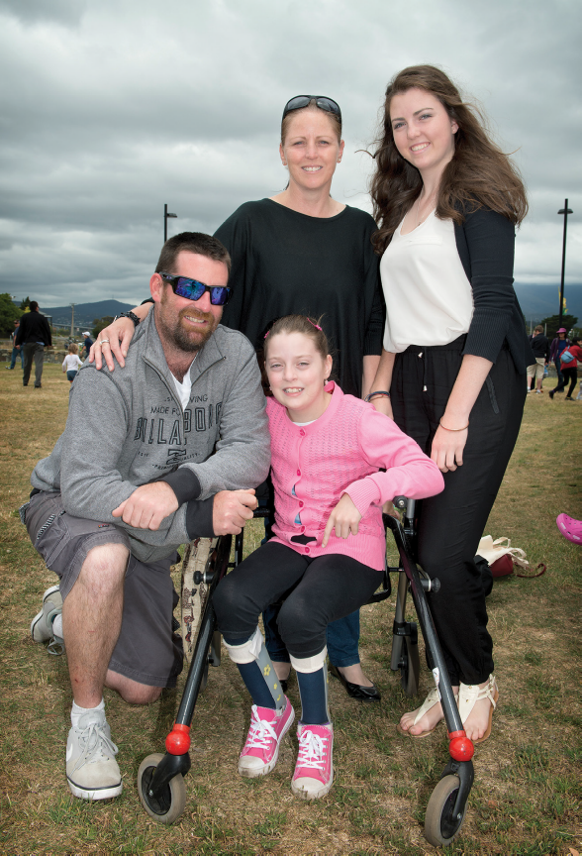
International Day of People with Disability (IDPwD)
event in Clarence.

This plan is about access and inclusion from the view of people with a disability. It was put together with the help of people with a disability.

Council has said it will work together with people who have a disability. We want to keep improving and creating an accessible and inclusive community and spaces for people of all ages and abilities.

What did people say?
Council talked to people with a disability. We also talked to families, carers, and organisations.
People said these three (3) areas were the most important for council to do:

Lead
- Keep getting better.
- Keep talking with the community.
- Keep connecting with support organisations.

Create
- Make information and events inclusive and accessible.
- Make access to services and programs better.
- Make access to arts and events better.

Develop
- Have places and spaces that are easier to get to and use.
- Have better access to beaches.
- Have safer and better ways to get around.

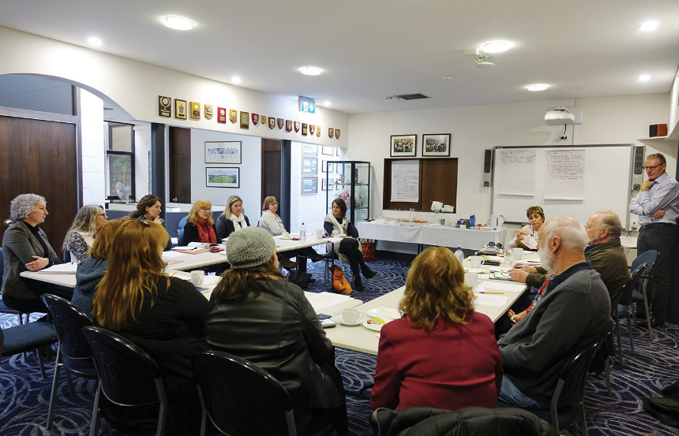
Talking with people in the community.
What will we do?
Over the next five (5) years council will keep working together with people who have a disability, families, carers, and organisations to:

 Change how we talk about disability.
Make people more aware.
Include access and inclusion in all that council does.
Create better places to live.

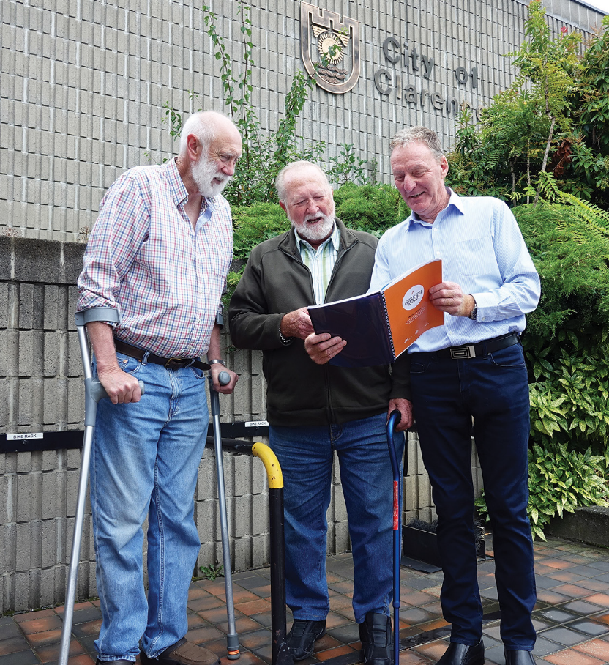
Some of council's Disability Access Advisory Committee.

Make it better to get the information you need.
Create better ways to get involved in events and activities.
Work with others to help promote and develop programs.
Celebrate people with disability in our community.

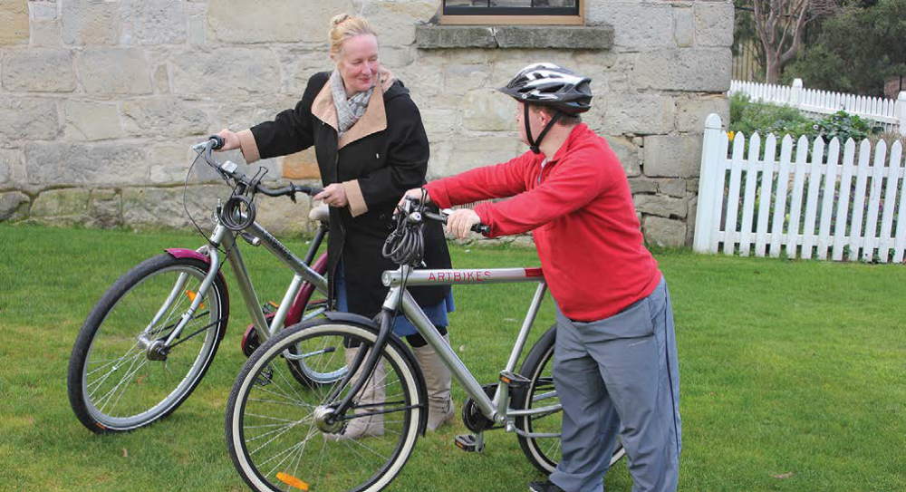
Postcard Project.

Work on making places you use easier to get to and in.
Make it easier to get on a beach.
Help to make getting around easier.
Create play spaces that include everyone.

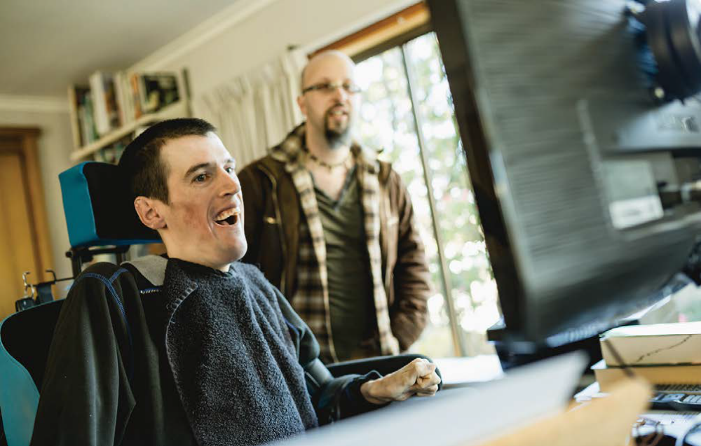
Postcard Project with Mosaic Services.

What do you think?
Let us know what you like and don’t like about the plan, and if there is anything missing.

There are four (4) ways to do this:
- Go on council’s website. There are three (3) questions to answer, or you can make a short 60 second video:
https://www.yoursay.ccc.tas.gov.au/access-and-inclusion

- Write to us:

Julie Andersson
Access Plan Consultation
Clarence City Council
PO Box 96
Rosny Park TAS 7018

- Email us at access@ccc.tas.gov.au.

- Call and talk with Julie on 03 6217 9597 or meet in person.

Let us know what you think before the 1 November 2021.

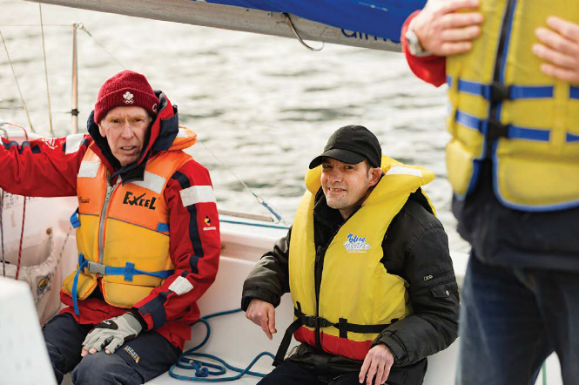
Postcard Project with Sailability.

